DroneTech for Social Good and Economic Development in
Somerset & Devon

Research & Advisory Services for the South West Future Flight Innovation Zone (SWFFIZ)

Natural Environment Support Paper

April 2025

Contents

1 Introduction
2 Context for Deploying DroneTech in the Protection and Management of the Natural Environment
3 DroneTech Applications relevant to the Natural Environment
4 The Adoption Challenge
5 Conclusions and Recommendations

Appendices

A List of Consultees
B Workshop Structure March 2025
C Use Cases for DroneTech in the Natural Environment

List of Acronyms

ARPAS: Association of Remotely Piloted Aircraft Systems Trade Association for UK Drone Industry
BVLOS: Beyond Visual Line of Sight
CAA: Civil Aviation Authority
CPC: Connected Places Catapult
DfT: Department for Transport
eVLOS: Extended Visual Line of Sight
FFIZ: Future Flight Innovation Zone
NATS: National Air Traffic Serves
SC: Somerset Council
UAVs: Unmanned Aerial Vehicles
VLOS: Visual Line of Sight
VTOL: Vertical Take Off and Landing

1 Introduction

This paper focusses on opportunities for environmental bodies in the South West Future Flight Innovation Zone (SWFFIZ) to undertake more of their core activities using ‘DroneTech. For example, drones now have the capability to carry high quality imaging equipment, and this is transforming the way in which environmental survey data is collected and analysed. The technology offers environmental bodies a means to do more with less over time, and there is a pressing need for innovation of this kind in a sector which is heavily reliant on ‘unprotected’ public funding.

This paper provides a high-level summary of the context for deploying DroneTech in the protection and management of the natural environment. Emerging evidence on the benefits of the technology is presented alongside the challenges of deploying DroneTech locally. Finally, conclusions and recommendations are presented. EiBC’s work has not reviewed the use of drones in the commercial agricultural sector, except insofar as there are explicit overlaps with landscape and wildlife conservation objectives. There is a growing market for DroneTech in arable farming systems in particular, and although this is a relatively small part of the agricultural sector in the South West, the opportunities for deploying DroneTech more generally in South West agriculture merits further consideration.

In 2024 EiBC undertook a preliminary study for Somerset Council (SC) identifying ways in which DroneTech was being deployed for the public good. As a result of that study, applications for DroneTech in the management of the natural environment and buildings & physical assets were identified as promising opportunity areas, alongside rapid response defibrillators. The purpose of this work has been to look at each in further detail and consider how collectively they could catalyse a new business cluster around drone and related technologies in the SWFFIZ area.

This paper is part of a suite of EiBC outputs that includes an accompanying Support Paper on DroneTech for Buildings & Physical Asset Management, a short assessment of the case for Dronetech and Defibrillators, and an overarching SWFFIZ Overview Report that brings the key findings from all strands of the project together in one place.

This project was undertaken between January 2025 and March 2025. The work programme involved desk research, consultations with a wide range of environmental bodies (see Appendix A) and a workshop with 60+ delegates at the Taunton Digital Innovation Centre on 12 March 2025 with representatives from local authorities, the NHS, environmental organisations, housing associations, universities, colleges, DroneTech operators, industry, and the Civil Aviation Authority (CAA) in attendance. See Appendix B for details of this event including attendees.

We would like to thank the Chairman of ARPAS, Graham Brown, for his invaluable advice, connections and inputs into this Paper. We would also like to thank Corinne Matthews, who is the Aerospace and Energy Lead at Somerset Council (SC), for the open and collaborative manner in which we have been able to undertake this work.

2 Context for Deploying DroneTech in the Protection and Management of the Natural Environment
Local authorities and environmental bodies are responsible for the protection and management of the natural environment. Much of this relates to the delivery of statutory obligations which are laid down by Government. These are legislative requirements that environmental bodies are obliged to deliver, and which cannot be put on the back burner. However, environmental bodies are heavily reliant on public funding. More innovation, digitalisation and efficiency is the only long-term solution to continuing to meet these obligations.

Some of the key statutory obligations relating to the protection and management of the natural environment are summarised below. In the next section some of the opportunities for addressing these challenges and working smarter using DroneTech are considered.

Protection and Management of Designated Landscapes in the SWFFIZ Area
There are 2 National Parks and 6 National Landscapes (formerly AONBs) in Somerset and Devon:
- Dartmoor
- Exmoor
- Blackdown Hills (Devon / Somerset)
- East Devon
- North Devon
- Quantock Hills (Somerset)
- South Devon
- Tamar Valley (Devon)
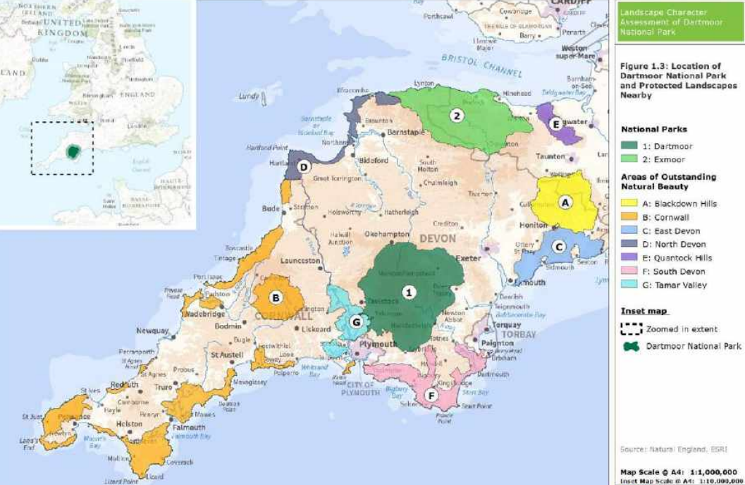
Source: Dartmoor National Park
Along with National Parks, National Landscapes have the highest status of planning protection. The purpose of a National Landscape is to protect and enhance the natural beauty and habitats of the area, with particular reference to its management plan, which is reviewed every five years.
By 2030 National Landscapes in England are also expected to deliver on:
- The creation / restoration of 100,000 hectares of wildlife-rich habitat (approximately nine times the size of Manchester)
- The restoration of at least 200,000 hectares of land within SSSIs to a 'favourable condition' (an area greater than the size of London)
- Planting / regenerating 36,000 hectares of woodland (an area just smaller than Isle of Wight).
Protection and Management of Designated Wildlife Sites in the SWFFIZ Area
There is a hierarchy of protected wildlife sites which have statutory protection:
European Significance: Special Areas of Conservation (SACs) are protected sites considered to be most in need of conservation at a European level (excluding birds which are covered by Special Protection Areas).
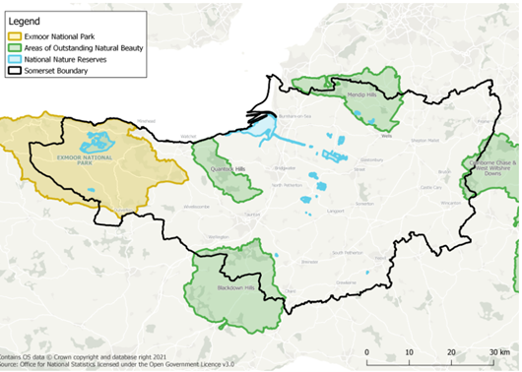
National Significance: Sites of Special Scientific Interest (SSSIs) represent the country’s best wildlife and geological sites. Natural England are responsible for their designation and the 'site management statement' which sets out management responsibilities. Public bodies which own or occupy an SSSI have a duty to manage it properly. There are also National Nature Reserves (224 in England). Natural England manages two thirds of NNRs with the remaining reserves managed by authorities such as the Forestry Commission and the RSPB. For illustrative purposes, maps of protected wildlife sites in Somerset are shown below and there will be a similar network of sites in Devon.
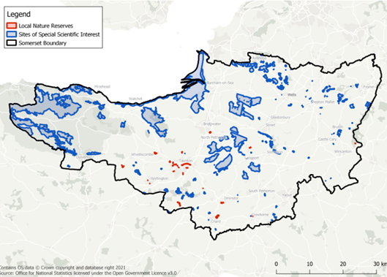
Local Significance: Local Nature Reserves are created by local authorities. The local authority must control the land, either through ownership or a lease or an agreement with the owner. At least part of it should be publicly accessible. There are 22 LNRs in Somerset as shown below. Local Wildlife Sites are identified and selected by local community partnerships. They are not legally protected in the same way as national and European sites, but they are safeguarded through local planning policies. Local Wildlife Trusts work in partnership with landowners to manage these areas. There are 2,000+ local wildlife sites in Somerset.

Protection and Management of River, Coastline and Other Countryside Assets
DEFRA has overall national policy responsibility for flood and coastal erosion risk management (FCERM) in England, but delivery responsibility falls to the Environment Agency, local authorities and internal drainage boards. These risk management authorities (including Somerset Council and Devon CC) and others have their own responsibilities and powers that they can use in order to carry out these responsibilities. Regional flood and coastal committees provide a link between flood risk management authorities and other relevant bodies. They ensure coherent plans are in place for: identifying, communicating and managing flood and coastal erosion risks across catchments and shorelines; and promoting efficient, targeted investment in flood and coastal erosion risk management. The SWFFIZ area includes the Wessex and South West regional areas.
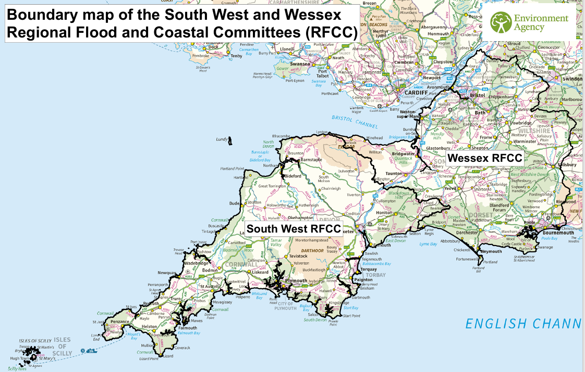
Local authorities also have responsibilities for a wide range of other countryside assets such as the rights of way network, country parks, cycle paths, associated car parks etc.
Local Nature Recovery Strategies
The requirement to prepare Local Nature Recovery Strategies was introduced by the Environment Act 2021. There are 48 strategy areas in England. Each Local Nature Recovery Strategy must: agree priorities for the recovery of the natural environment; map the most valuable existing areas; and set out specific proposals for creating or improving habitats.

Local Nature Recovery Strategies have a key role to play in meeting the UK’s international environmental commitments. At the UN Biodiversity Summit (COP15) in 2022 the global 30by30 target was agreed which aims to effectively conserve and manage 30% of the Earth's land, inland water, coastal, and marine areas by 2030. On 26 February 2025 the UK Government reconfirmed its commitment to the implementation of UN COP15 biodiversity framework by publishing its National Biodiversity Strategy & Action Plan (NBSAP) including commitments to:

- Expand protected areas to at least 30% of the land and seas
- Reduce pollution from all sources to levels that are not harmful to biodiversity
- Enhance biodiversity and sustainability in agriculture, aquaculture, fisheries, and forestry
- Ensure sustainable, safe and legal harvesting and trade of wild species.

Work on Somerset’s LNRS has been in progress for 2 years and it is due to go out to public consultation in May 2025. It will then be reviewed and updated every 5 years. In Devon, the Government has nominated Devon County Council as the Responsible Authority to develop the Local Nature Recovery Strategy in conjunction with Supporting Authorities and other interested stakeholders. Supporting Authorities include East Devon District, Teignbridge, South Hams, West Devon, Torridge, North Devon, Exeter City, Mid Devon, Torbay Council and Plymouth City Council), Dartmoor National Park, Exmoor National Park and Natural England.

Biodiversity Net Gain
Biodiversity Net Gain (BNG) originates from the Environment Act 2021 which makes it a legal requirement that a BNG of at least 10% must be delivered on new developments. BNG became mandatory for major development sites from 12 February 2024 and for small sites from 2 April 2024. Implementation for Nationally Significant Infrastructure Projects is planned for later in 2025.

BNG can be delivered on-site, off-site or via a new statutory biodiversity credits scheme. Ideally the 10% net gain should be delivered on the development site itself but if space and circumstances do not allow this, provision on a separate site or a mixture of the two is permissible. Local authorities are expected to bring forward sites which can be used for ‘offsetting’ in this way. The management of the habitat created must then be secured by legal agreement for a minimum period of 30 years.

If BNG cannot be achieved either on-site or elsewhere locally, the Environment Act makes provision for the Secretary of State to set up a system of statutory biodiversity credits that will be invested in habitat creation. The biodiversity credits scheme allows environmental bodies to sell biodiversity credits to developers.

It is early days but BNG represents a big workload for local authorities such as SC. In Somerset the local authority has put out a call for ‘offsetting’ sites and about 70 sites have come forward. An environmental database needs to be constructed with baseline data on these 70 sites, and then it will need to be regularly updated for monitoring and reporting purposes. At present, there is only person in SC with the required botanical skills.

3 DroneTech Applications relevant to the Natural Environment

This section begins by highlighting some of the regulatory issues that affect the deployment of DroneTech in the natural environment. Then the main opportunity areas are discussed with a range of examples both from the local area and across the country as a whole.

Current Regulatory Environment and Implications for the Natural Environment
Currently most drone operations are performed within ‘Visual Line of Sight’ (VLOS) with the drone pilot maintaining continuous unaided visual contact with the drone. This is a significant constraint on the application of the technology for environmental uses. For example, rather than sending up a drone once to carry out some landscape-level monitoring, it has to be done in a more piecemeal way and ends up being relatively expensive.
Many more applications will be unlocked when Beyond Visual Line of Sight (BVLOS) flying is possible. Being able to fly BVLOS is a vital component in realising the full potential of drone technology for the natural environment. Currently, aviation regulations permit BVLOS operations only by exception and largely in segregated airspace. However, over the period 2024-2027 the Civil Aviation Authority (CAA) expects BVLOS operations to move from the current controlled environments which are approved for testing for up to 90 days, to every-day BVLOS alongside other forms of air traffic in non-segregated airspace (UK Future of Flight Action Plan, March 2024). This will reduce many of the constraints which currently hinder the practical and efficient deployment of DroneTech generally and for specifically for environmental applications.
Noise is an issue for all DroneTech applications in terms of public acceptance of new projects and business activities locally. However, there is a further tier of issues relating to noise for activities that relate to the natural environment. This was raised by attendees at the Study Workshop. For a start, there is legislation which restricts flights in sensitive wildlife areas. The Wildlife & Countryside Act (1981) says that where the use of a drone is likely to cause disturbance to any schedule 1 bird species, alternatives must be sought. Similarly, the CAA states that flights may be restricted at SSSIs where there is a risk of wildlife disturbance. Landowners can also prohibit the use of drones over their land with the power of byelaws linked to the protection of wildlife and the natural environment. Thus, while it is not entirely prohibited, flying drones in sensitive wildlife areas in the UK can be highly restricted and ways of working around this will need special attention.
Opportunity Areas for DroneTech – Local and National Examples
The deployment of DroneTech in the natural environment is still in a nascent stage. There are some practical examples, but these are relatively few compared to the more mature asset management market. The main types of applications to date are listed below along with brief details of the examples we have reviewed. Further details on the use cases are provided in Appendix 3.

Land and Habitat Surveys
Quantock Hills National Landscape Woodland Disease Monitoring  2024 | 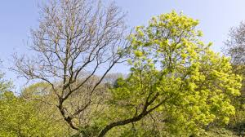  
Plymouth Marine Laboratory Mapping of Shallow Waters  2025 | 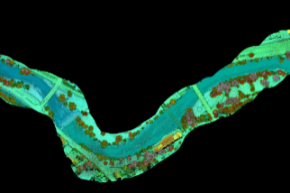  
Wildlife Surveys
Quantock Hills National Landscape Deer Survey  2024 | 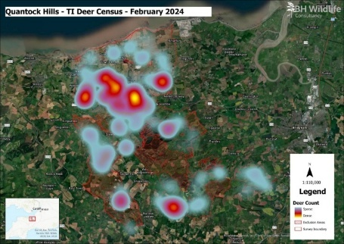
Practical Habitat Management
Project “Drone RePeat” Peatland Restoration  2024 |   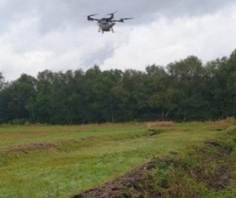
Enforcement
Buckinghamshire Council in-house use of drones to investigate breaches of planning controls  2024 | 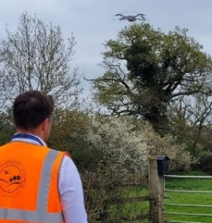  
Promoting Sustainable Agriculture
Autospray Systems – Precision Spraying by Drone  2023 | 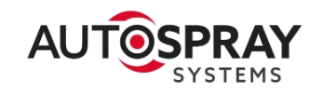  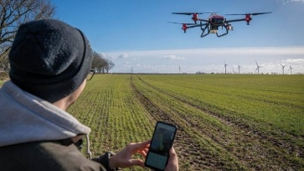
Reducing Pesticides / Herbicide Use in the Management of Green Spaces
RUAS herbicide spraying service for difficult to reach non-native invasive species of vegetation on critical rail infrastructure  Early 2020s |   
Drone Skills & Training for the Natural Environment
‘WildDrone’ is an international PhD training network on drones and companion autonomous systems for nature conservation | 

4 The Adoption Challenge

The use of drone technology in the protection and management of the natural environment is still in a nascent phase. Compared to other applications such as building asset management, there is still a low awareness of the capabilities of DroneTech and relatively few examples of the technology being deployed on practical projects. It is, therefore, important that awareness raising activity continues in potential user communities.

Scaling Demand – Public Sector Demonstrator

Notwithstanding it is early days for DroneTech in the natural environment, the way the technology is being deployed currently is ad hoc, piecemeal and fragmented. This undermines the potential for creating a sustainable market for the technology. There is a need to ‘scale’ the demand so this emerging market can operate more efficiently and predictably. One role for SWFFIZ could be to catalyse the creation of larger customers for DroneTech in the natural environment.

The new Somerset Council represents a great opportunity to demonstrate how this could be done for a local authority. The creation of one authority for Somerset means all environmental responsibilities have been brought together under one organisation. Somerset Council’s Climate and Natural Environment Directorate is around 150 staff. In addition, the Council has many other responsibilities that relate to the environment such as planning, enforcement, pollution, emergency & rapid response etc.

In the Climate and Natural Environment Directorate, there has been a lot of upheaval from bringing together 5 previous councils with very different levels of knowledge and resource for environmental work. But this is an opportunity too – the reorganisation means the environment service has more scope to innovate because it is a larger entity, it delivers services at greater scale, and staff are more open to doing things differently than they might have been in the past.

Much of the work that comes under the Climate and Natural Environment team relates to the delivery of statutory services. These are not things that can be put on the backburner – they are legislative requirements that the Council is obliged to deliver. There is a huge amount of work to be done, and senior management is open to new technology which makes their resources stretch further. The table below summarises the main responsibility areas that fall under the Climate and Natural Environment team (most being statutory requirements), and the opportunities for DroneTech to improve service delivery and efficiency.

Summary of SC Natural Environment Responsibility Areas and DroneTech Opportunities
Somerset Council Responsibility Area | DroneTech Applications
Protection of designated landscapes – there are 5 national protected landscapes of which 2 are managed by Somerset Council | - Land & habitat surveys  - Wildlife surveys  - Environmental monitoring & reporting  - Conservation management
Green estates – responsible for the country parks eg. Ham Hill, Yeovil and NNRs such as Chard Reservoir. There are 22 NNRs in Somerset of which 12 are owned by the Council) | - Conservation management  - Wildlife surveys  - Reducing pesticide and herbicide use in the management of green spaces
Local Nature Recovery Strategy - Work on Somerset’s LNRS has been in progress for 2 years and it is due to go out to consultation in May 2025. It must then be reviewed and updated every 5 years. The UK has committed to protect 30% of land and sea for nature by 2030 (30by30) and the LNRS is key to achieving this target and it is a statutory obligation for LAs in England to report on this to Government | - Land & habitat surveys  - Environmental monitoring & reporting  - Conservation management
Biodiversity Net Gain / Ecology - Somerset Council has been inviting applications from landowners to create ‘offset sites’ and about 70 are being considered. A huge amount of work is needed to establish baseline data, agree management and monitor over the required 30- year period. But also, an opportunity for income generation from developer contributions and green credits | - Land & habitat surveys  - Environmental monitoring & reporting  - Conservation management  - Supporting sustainable agriculture
Flood and Coastline – looks after flood protection assets and linked to the Council’s civil contingencies function. Somerset has 45 miles of coastline which must be managed | - Land & habitat surveys
Climate Strategy

EiBC recommends that Somerset Council Climate & Natural Environment should be supported to become a local authority demonstrator for DroneTech in the Natural Environment. The aims of the project will be to demonstrate:
- How demand for DroneTech in the natural environment can be scaled, creating ‘bigger’ customers with more predictable requirements
- How DroneTech can help local authorities to work more efficiency and productivity in carrying out their statutory environmental obligations
- How DroneTech can help local authorities to professionalise and capture the commercial opportunities from Biodiversity Net Gain. If the proper baseline work and environmental intelligence is gathered now, this could underpin long-term income generation from developers to fund other essential services.

Scaling Demand – Private Sector Demonstrator

One of the reasons for the current piecemeal and fragmented deployment of DroneTech is that most drone operations have to be performed within ‘Visual Line of Sight’ (VLOS). This is a significant constraint on the application of the technology for environmental uses.
Many more applications will be unlocked when Beyond Visual Line of Sight (BVLOS) flying is possible. Being able to fly BVLOS is a vital component in realising the full potential of drone technology for the natural environment.
Many landowners and farmers are both commercial agricultural producers and ‘paid’ custodians of the natural environment through their participation in DEFRA and other conservation programmes. Their operations depend on having good information about their crops, livestock and biodiversity goals. Currently much of this information is gathered from ground-based inspection which takes a lot of staff time. It is also a ‘reactive’ approach with decisions made after information has been received when considerable damage could already have been done.
DroneTech is part of a solution to this problem. The quality of imaging equipment which can be carried on drones means high resolution data collection is feasible. There is also the possibility of introducing machine learning, so over time the data can be used to predict management issues. For example, if a combination of particular weather conditions and soil type is likely to exacerbate weed growth and crowd-out a crop in a particular location or cause excess run-off into a watercourse which is being managed for environmental gain.
The problem is that VLOS makes this too complicated and expensive to do at scale. Ideally a demonstrator would be established where farmers and landowners come together and in conjunction with the CAA, agree protocols for collecting BVLOS data on specific land and habitat parameters in a designated trial area. This would test the appetite of land-based businesses to pay for DroneTech services and if successful could be recreated elsewhere to create ‘bigger customers’ and drive economies of scale.
Possible Demonstration Locations/Partners

Duchy College (which has two campuses at Stoke Climsland on the Devon/Cornwall border and Rosewarne just outside Camborne) and Bicton College (based in East Devon) are part of the Cornwall Colleges Group. At the heart of both these land-based colleges is the is the Rural Business School (RBS). With strong industry ties, RBS supports innovation, skills development and practical solutions across farming, food security and rural enterprise. It has been instrumental in the development of Agri-Environmental Living Labs at both campuses and has procured a range of drone and imagery equipment to support that work.

It is interested in using its resources and contacts with the local farming community to establish a demonstrator project with the aim of enabling cost-effective agri-environmental monitoring through integrated BVLOS drone operations. For example, at Bicton it has a close working relationship with Clinton Devon Estates which is a land management and property development company which manages the Devonshire estates belonging to Baron Clinton, the largest private landowner in Devon. The estate owns and manages over 10,000 hectares of farmland including 1,800 hectares of woodland.

Within the estate are the East Devon Pebblebed Heaths. The Pebblebed Heaths are amongst the most important conservation sites in Europe due to the rarity of the habitats and species found. Covering over 1,400 hectares, they comprise the single biggest expanse of lowland heathland in Devon. The main core of the Pebblebed Heaths is notified as a NNR and SSSI. Part of the site is also designated as a Special Area of Conservation (SAC) and a Special Protection Area (SPA) under the EU Birds Directive and the EU Habitats Directive. The East Devon Protected Landscape covers all of the Pebblebed Heaths area. It is not managed as a commercial enterprise, but as a partnership between the Estate, government grants and the East Devon Pebblebed Heaths Conservation Trust, which employs full-time wardens and volunteers to look after the terrain. Last year, Clinton Devon Estates bid successfully to DEFRA for a 2-year Landscape Recovery development project, ‘Heaths to Sea’, in the Pebblebed Heath area. It is currently tendering for consultants to undertake baseline carbon and soils analysis across the project area in advance of management plans being implemented.

The Rural Business School at Bicton College is looking to use this area and some of the surrounding farmland for a 10-month project which would investigate the feasibility of establishing an approved BVLOS drone flight plan as part of the process of establishing an autonomous, integrated agri-environmental monitoring database for the area.

EiBC recommends that Duchy College or a similar project should be supported as a demonstrator for (BVLOS) DroneTech in the Natural Environment. The aims of the project will be to demonstrate:
- The cost-effectiveness of DroneTech for environmental monitoring: BVLOS operations will significantly reduce the operational costs associated with current drone surveys and ground-based data collection
- The quality of data which can be collected by integrating multi-sensor drone data with other Earth Observation data sources. Plus, the ability of machine learning to generate better analysis and predictive intelligence from the data
- Improved Decision-Making for Land Managers: Timely and accurate data will empower landowners and managers to make informed decisions regarding resource management, precision agriculture, and environmental stewardship
- Support for Sustainable Land Management: The project will contribute to a better understanding of environmental changes and the effectiveness of sustainable practices, supporting landscape recovery initiatives and biodiversity conservation
- Development of New Technologies and Services: The project will foster innovation in drone-based remote sensing, data analytics, and the development of tailored products and services for the land use sector, including those supporting short and sustainable food supply chains and payments for ecosystem services.

5 Conclusions and Recommendations

The conclusions and recommendations from this support paper are:
- The way that DroneTech is being deployed currently is ad hoc, piecemeal and fragmented. There is a need to aggregate and stimulate demand to scale its potential use. SWFFIZ should therefore seek to catalyse the creation of larger customers for DroneTech services in the natural environment market.
- Somerset Council Climate & Natural Environment should be supported to become a local authority demonstrator for DroneTech in the natural environment with the aim of: creating a ‘bigger’ customer with more predictable requirements for the market; helping local authorities to work more efficiency and productivity in carrying out their statutory environmental obligations; and capitalising on the opportunities to professionalise and capture the commercial opportunities from Biodiversity Net Gain.
- Being able to fly BVLOS is vital to realising the full potential of drone technology for the natural environment. Ideally a private sector demonstrator should also be established where farmers and landowners come together and in conjunction with the CAA, agree protocols for collecting BVLOS data on specific land and habitat parameters in a designated trial area. This would test the appetite of land-based businesses to pay for DroneTech services and if successful could be recreated elsewhere to create ‘bigger customers’ and drive economies of scale.
- EiBC’s work has not reviewed the use of drones in the commercial agricultural sector, except insofar as there are explicit overlaps with landscape and wildlife conservation objectives. There is a growing market for DroneTech in arable farming systems in particular, and although this is a relatively small part of the agricultural sector in the South West, the opportunities for deploying DroneTech more generally in the South West agricultural sector merit further consideration.
- Noise is an issue for all DroneTech applications in terms of public acceptance of new projects and activities. However, it is a particularly sensitive issue in protected environmental areas and local byelaws etc could restrict activity. Ways of working around this will need attention.
- The use of drone technology in the protection and management of the natural environment is still in a nascent phase. Awareness raising work on the capabilities of the technology needs to continue in potential user communities

A Consultees

B Workshop Structure March 2025

C Use Cases for DroneTech in the Natural Environment
Land and Habitat Surveys
Quantock Hills National Landscape Woodland Disease Monitoring: The team has purchased a drone and trained staff to undertake different types of habitat monitoring. For example, a survey was undertaken of a 40ha woodland to assess the level of Ash dieback caused by the fungus Hymenoscyphus fraxineus. There is no cure for ash dieback, so the only option is to manage the situation which involves removing trees that pose a danger and compensating for habitat loss through planting other suitable species. The drone survey was a much more efficient way of collecting the necessary baseline data for the management plan. It took 2-3 hrs staff time compared to a full day sending a ranger into the site, plus it reduced the risks of having staff on site and gaining access to restricted or difficult to reach areas.

The range of land and habitat surveys being conducted across the country with new drone technology is too extensive to cover here. A good summary is provided in NERC’s 2024 review of the role of drones in nature conservation. It articulates the current state-of-play for drone technology within environmental research as adopted by NERC Centres and Collaborating Institutes in different environmental disciplines.
One of the outcomes of the NERC research has been funding for a Plymouth Marine Laboratory drone project which aims to revolutionise how underwater environments are mapped, particularly shallow waters like river sections and coastal areas with low turbidity. Mapping of shallow waters is especially vital for studying blue carbon habitats such as mangroves, seagrasses, and tidal marshes as these are some of the most efficient natural carbon sinks on Earth. These habitats store and sequester carbon at rates far exceeding tropical forests but mapping their underwater terrain and estimating carbon storage has been a major challenge.
While bathymetry of the seabed or rivers can be obtained using other instruments such as multibeam echosounders, these sensors cannot be deployed in very shallow waters. The project begins in 2025 and will use state of the art equipment that will allow more precise quantification of coastal erosion and the mapping of blue carbon ecosystems, such as kelp and seagrass, to better understand their lifecycle, improve modelling and estimate how much carbon they store. In turn this will pave the way to promote the restoration of these habitats for carbon sequestration. It will also help improve models for river flow and river discharge in support of flood prevention. This is just one example of PML’s expertise in using drones for environmental monitoring which is extensive.
Wildlife Surveys
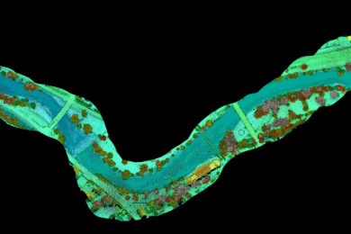
Quantock Hills National Landscape Deer Count: The wild deer of the Quantocks form an important part of its ecology and cultural history. The opportunities to observe red deer, are valued highly by locals as well as visitors to the area. However, without careful management excessive deer numbers can build up and lead to detrimental impacts on biodiversity, farming, timber production, and on the health and body condition of the deer themselves. To this end, an annual spring count of deer numbers has been undertaken on the Quantock Hills since 1990. But wild deer are notoriously difficult to count accurately as many tend to hide in cover during daylight hours.

Concerns about substantial numbers of deer being missed in high standing crops and other concealing cover during the annual count led to a drone based thermal deer count being organised in 2024 (alongside the manual count). The manual survey counted a total of 1,246 deer and the drone survey a total of 1,789. The much greater numbers (alongside a growing population trend) acted as catalyst for the Quantock Deer Management & Conservation Group to collaboratively develop a new Management Plan for the sustainable management of deer into the future. This was greatly aided by the outputs from the drone survey which visualised the parts of the Quantocks with the greatest population concentrations very clearly.
Practical Habitat Management
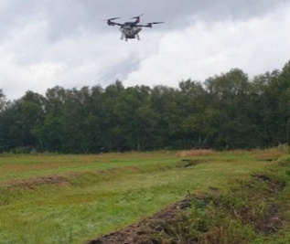
Peatland degradation has led to the release of vast amounts of carbon dioxide into the atmosphere. Restoring these ecosystems would make a valuable contribution to combating climate change. Traditional methods of rewetting and reseeding degraded peatlands are labour-intensive and challenging due to the often remote and waterlogged nature of the terrain. Project “Drone RePeat” was recently awarded £500,000 by Natural England to use drones to survey, analyse and then precision-spray peatlands to reseed them with Typha latifolia, a plant well-suited to wet environments. In addition to ecological restoration, the project encourages the cultivation of commercially viable crops like soft berries and sphagnum moss on peat boglands, creating economic incentives for landowners to realise value from these difficult-to-manage landscapes.

The Drone RePeat project is being led by the SEAD Artists consortia which currently include the following organisations: Aerofirm – a safety case expert around BVLOS flight; AutoSpray Systems – the only UK company permitted to use drones for land spraying and spreading, allowing aerial application of seeds, spores, fertiliser and nutrients to England’s peatlands; DronePrep – architects of the first real-world drone deliveries for NHS and Royal Mail, and experts in land ownership and airspace approvals; Skypointe a technology provider TAPSW a software firm.
Enforcement
Local authorities are responsible for a variety of enforcement activities relating to the natural environment. In 2024 Buckingham County Council gave a presentation to the RTPI Planning Enforcement Conference on its use of drone technology to investigate breaches of planning controls. The Council presented its experience of procuring a drone, drawing up a usage policy, documenting flight information, insurance, safety and staff training. It is currently demonstrating the capabilities and benefits of the technology, which are believed to be considerable eg. around issues such as planning breaches, fly tipping etc relating to the natural environment and for monitoring transport, pollution and many other areas of responsibility across the Council.
Promoting Sustainable Agriculture
Until recently, the use of drones for agricultural spraying was limited by strict CAA regulations with take-off weight limited at 25kgs and a ban on the release of materials from the air. However, in 2023 the CAA granted its first operational authorisation for agricultural spraying to UK drone specialist AutoSpray Systems. While the regulatory framework for drone pesticide spraying is still evolving, the new permit allows trained operators to utilise drones for specific applications, adhering to strict safety guidelines to mitigate risks such as spray drift. The technology delivers a range of environmental benefits as well as the cost savings to the farmer from automation. Running on batteries, drones reduce diesel use and lower greenhouse gas emissions. The technology is also designed for precision application which reduces the amount of chemicals used and the run-off (into nearby waterways). Unlike traditional methods, drones can pinpoint specific problem areas, reducing the overall volume of chemicals used and minimising waste.

For example, there are use cases targeting black grass in fields of oilseed rape which have achieved significant cost savings. Aerial operations also protect the soil from compaction which is beneficial to the environment. The market is set for expansion. In April 2025, France opened its skies to aerial pesticide spraying, with a distinctly green twist. A new bill, passed on April 9 by the French parliament, authorises the use of drones to spray low-risk pesticides and organic-friendly treatments on specific crops and terrains.
Reducing Pesticides / Herbicide Use in the Management of Green Spaces
RUAS is one of the UK’s leading drone service providers. It has drones equipped with the latest technology, including electro-optical (EO) and thermal capabilities which gives it the ability to work across a range of industries such as rail, construction, creative media, surveying, conservation, energy, emergency services and infrastructure. In 2021 it secured Innovate UK funding to design and build an unmanned aerial precision sprayer (UAPS) to be attached to a drone.

The immediate application was to provide an improved herbicide service for difficult to reach non-native invasive species of vegetation (e.g. buddleia on brickwork) on critical rail infrastructure (e.g. bridges, retaining walls, embankments, cuttings and tunnel entrances). UAPS saves time, resource, reduces risk to life and can save money by preventing further damage to much of the aging railway infrastructure. Further benefits include using lesser amounts of pesticide due to the preciseness of the sprayer compared to existing methods of delivery. While UAPS was designed to operate in the railway environment, the utility of the sprayer provides wider opportunities for estates and green spaces management etc. (regulation permitting).
Drone Skills & Training for the Natural Environment
WildDrone is an international training network under the EU Marie Sklodowska Curie Actions programme with partners from across Europe and Africa revolutionise wildlife conservation practices by using drone technology to monitor wildlife populations and track their movements etc. The network has received funding from the EU (€ 2,777,853.60), UKRI (£ 530,503), and the Swiss State Secretariat for Education, Research and Innovation (CHF 319,412.00). Over the period 2023 – 2026 it will recruit and train a total of 13 PhD students to realise the full potential of drones and companion autonomous systems for nature conservation missions. One of the recommendations from NERC’s 2024 review of the role of drones in nature conservation is that one or more geographically accessible CAA-approved training centre(s) should be established to build capacity and capability to roll out drone technology in the sector.

EiBC has used the term DroneTech deliberately – as this conveys much more clearly that it is the data, software and analysis that sits behind these aerial vehicles, that delivers much of the value added for customers.

